OAADSS peer mentor profile
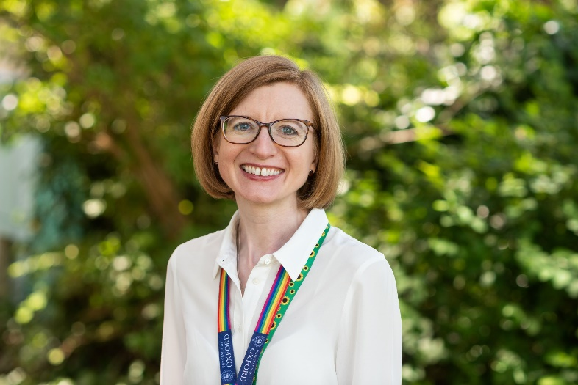
Gender: female; Pronouns: she/her
Likes: my job (university teaching and research), routines, reading, the sea, cake, pottering in card and stationery shops
Dislikes: injustice, unclear plans, group activities, liquorice, beer
Name: Helen
What would you like to do at OAADSS?
○ Help people waiting for diagnosis
What type of people do you think you would get on with/could relate to? probably most people, but especially professional women (of any age), students of any age, young people (especially university-age, given my job), and transgender/gender nonconforming people, people with experience of mental health conditions. I think my lived experience would be less useful if someone is specifically thinking about their autistic experience as a parent or is particularly wanting support as a person of colour.
What type of person are you? white middle-aged cis woman, married with grown-up stepchildren; university professor; a curious deep thinker but always looking to extract the humour from or inject the humour into a situation; proud Yorkshirewoman; INFJ.
When I’m not working I like to: listen to music (wide-ranging taste), run, walk up hills, sit and chat with close friends and family (only one or two at a time, mind…) over a glass of wine

